Data structures and Algorithms
Exercise 2: E-commerce Platform Search Function
using System;
using System.Collections.Generic;
class Product
{
public int ProductId { get; set; }
public string ProductName { get; set; }
public double Price { get; set; }
public Product(int id, string name, double price)
{
ProductId = id;
ProductName = name;
Price = price;
}
}
class Program
{
static void Main(string[] args)
{
List<Product> products = new List<Product>()
{
new Product(101, "Laptop", 50000),
new Product(102, "Mouse", 500),
new Product(103, "Keyboard", 1500),
new Product(104, "Monitor", 12000)
};
Console.Write("Enter product name to search: ");
string searchName = Console.ReadLine();
bool found = false;
foreach (Product p in products)
{
if (p.ProductName.Equals(searchName,
StringComparison.OrdinalIgnoreCase))
{
Console.WriteLine("\nProduct Found:");
Console.WriteLine("ID: " + p.ProductId);
Console.WriteLine("Name: " + p.ProductName);
Console.WriteLine("Price: Rs. " + p.Price);
found = true;
break;
}
}
if (!found)
{
Console.WriteLine("Product Not Found");
}

Console.ReadKey();
}
}
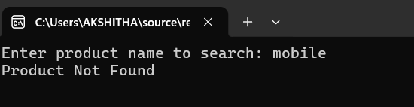

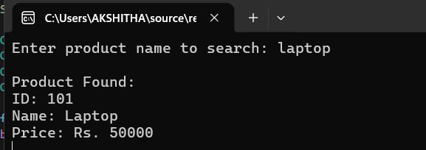

Exercise 7: Financial Forecasting
using System;

class Program
{
static void Main(string[] args)
{
Console.Write("Enter Initial Investment: ");
double principal = Convert.ToDouble(Console.ReadLine());
Console.Write("Enter Annual Interest Rate (%): ");
double rate = Convert.ToDouble(Console.ReadLine());
Console.Write("Enter Number of Years: ");
int years = Convert.ToInt32(Console.ReadLine());
double futureValue = principal * Math.Pow((1 + rate / 100), years);
Console.WriteLine("\nFinancial Forecast");
Console.WriteLine("------------------");
Console.WriteLine("Initial Investment: ₹" + principal);
Console.WriteLine("Interest Rate: " + rate + "%");
Console.WriteLine("Years: " + years);
Console.WriteLine("Future Value: Rs. " + futureValue);
Console.ReadKey();
}
}
